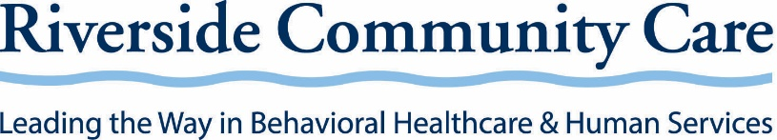

FOR IMMEDIATE RELEASE
June 1, 2021

Contact:
Alison Rivers
Director of Marketing and Communications
arivers@riversidecc.org
781-320-5398

Marsha Medalie to Be Named CEO of Riverside Community Care
Dedham, MA – Riverside Community Care, a non-profit leader in behavioral healthcare and human services, announced today that Marsha Medalie will assume the role of CEO effective July 1, 2021. Scott M. Bock, CEO and founder of the organization, is stepping down for medical reasons. Bock will stay on as an Executive Advisor.
Medalie, currently President at Riverside Community Care, has been with the organization since 1995 and served as Chief Operating Officer before becoming President. Prior to joining Riverside, Medalie served as CEO of Eastern Middlesex Human Services. She was also Executive Director of Whitman Counseling Center, a consultant, and spent many years as a private practice therapist. Medalie is a member of the Commonwealth’s Children’s Behavioral Health Advisory Council and received the Association for Behavioral Healthcare Robert Dorwart, M.D. Award for Mental Health in 2017. Medalie is passionate about finding ways to fully integrate behavioral health and human service programs so that people can get the best care possible, and she is actively involved in the national debate about healthcare reform.
Joseph Wadlinger, Chair of the Riverside Board of Directors, commented, “We have the utmost confidence in Marsha’s ability to lead the organization. Marsha and Scott have worked side-by-side for more than 25 years, making her uniquely capable of ensuring that Riverside Community Care remains an essential resource for those who need help. Marsha is extremely knowledgeable about Riverside’s operations, finances, and organizational growth strategy and has a strong management team in place. It’s remarkable that Scott grew Riverside from an organization of just six people in 1982 to nearly 2,000 talented and compassionate employees today. Scott’s dedication has helped tens of thousands of people across Massachusetts live fuller lives, and his vision is now allowing Riverside to have an international presence through technology – reaching millions in 20 countries. We fully endorse his decision to focus on his health and will continue to support him in that journey.”
Medalie commented, “It’s a privilege for me to carry on Scott’s vision and lead Riverside. Coming out of the pandemic, I feel we are at a pivotal point in behavioral healthcare, with much of the nation and world talking openly about behavioral health and the critical need for greater access and funding. I am also excited about Riverside’s potential to reach more people as we expand our innovative behavioral health screenings, trainings, and trauma response services to communities near and far. Scott did a remarkable job creating Riverside and positioning it as a leader in the industry. With a top-notch management team already in place, I’m honored to take the helm so that we can reach even further to help more in need.”
Riverside will begin recruiting to fill the role of President immediately.

Riverside Community Care (www.riversidecc.org) makes a difference in the lives of individuals, families, and communities through innovative and compassionate behavioral healthcare and human services. A community-based non-profit organization serving more than 40,000 people a year in Massachusetts, Riverside offers a wide range of mental healthcare, developmental and brain injury services, early childhood and youth programs, addiction treatment, trauma response, and more. Riverside’s digital learning platforms are reaching more than four million people around the globe, providing tools for education, prevention, and crisis management.

###

